**Name: Utkarsh Jain**

**Branch & Year: AI & ML, First Yr.**

**Section: f**

# Practical :

**Aim :** Design an informative Music Mania Website with the help of HTML programming and along with it using the different ways of CSS Style behaviour in it.

|  |  |
| --- | --- |
| FIRST YR B.TECH | COMPUTER WORKSHOP LAB MANUAL RECORD, RCOEM |

**Code**

<!DOCTYPE html>

<html lang="en">

<head>

    <meta charset="UTF-8">

    <meta name="viewport" content="width=device-width, initial-scale=1.0">

    <title> SunBurn Music Mania</title>

    <link rel="stylesheet" type="text/css" href="music.css">

</head>

<body >

    <header>

        <h1> SunBurn Music Mania</h1>

        <nav>

            <ul>

                <li><a href="#home">Home</a></li>

                <li><a href="#artists">Artists</a></li>

                <li><a href="#albums">Albums</a></li>

                <li><a href="#contact">Contact</a></li>

            </ul>

        </nav>

    </header>

    <section id="home">

        <h2>About Sunburn</h2>

        <p>Sunburn, a Percept Intellectual Property, is Asia’s Premiere Electronic Dance Music (EDM) Festival, and is ranked amongst the world’s biggest music festivals. Started in 2007 as a 3 day music festival in Goa, Sunburn has grown to become an aspirational lifestyle brand boasting an eclectic mix of music, entertainment, experiences and celebration that has seeded music tourism in India. Over the past decade, Sunburn has brought together renowned International and Indian artists to entertain hundreds of thousands of dance music lovers across the country and overseas, and positioned India as a prime dance festival destination to the world.

            The Sunburn Festival, Sunburn Reload, Sunburn Arena, Sunburn City Festival and Sunburn Campus formats have enabled a wide geographical and demographic reach pan India and abroad. Sunburn has the distinction of having brought down to India the world’s top 10 DJs, including Swedish House Mafia, Martin Garrix, Tiesto, Avicii, Hardwell, Deadmau5, Armin van Buuren, David Guetta, Afrojack, Above & Beyond, The Chainsmokers, Dimitri Vegas & Like Mike, Marshmello, Paul Van Dyk, Skazi, Pete Tong, Dash Berlin, and Nicky Romero. Sunburn has also made its successful debut overseas across Colombo, Sri Lanka; Khatmandu, Nepal; Dubai; Muscat; and Melbourne, Australia, thereby creating history to become the first successful indigenous Music IP to cross international shores.</p>

    </section>

    <section id="artists">

        <h2>Featured Artists</h2>

        <div class="artist">

            <img src="honey.jpeg" alt="Artist 1">

            <h3>Honey Singh</h3>

            <p style="font-family: Arial Rounded MT Bold";> Honey Singh, is an Indian music producer, Indi-pop singer and film actor. He started as a session and recording artist, and became a bhangra music producer. He has also begun to produce music for Bollywood films.</p>

        </div>

        <div class="artist">

            <img src="anjum.jpeg" alt="Artist 2">

            <h3>Talha Anjum</h3>

            <p style="font-family: Arial Rounded MT Bold";>Talha Anjum Rasheed is a Pakistani rapper, songwriter and lyricist. He is popularly known for being a member and co-founder of the Hip-hop band, Young Stunners along with Talhah Yunus, with Jokhay as music producer</p>

        </div>

        <div class="artist">

            <img src="charlie.jpeg" alt="Artist 3">

            <h3>Charlie Puth</h3>

            <p style="font-family: Arial Rounded MT Bold";>Charles Otto Puth Jr. is an American singer, songwriter, and record producer. His initial exposure came through the viral success of his song covers uploaded to YouTube</p>

        </div>

    </section>

    <section id="albums">

        <h2>Popular Albums</h2>

        <div class="album">

            <img src="honeys.jpeg" alt="Album 1">

            <h3>Honey 3.0</h3>

            <p> Sep 27 , 2023.</p>

            <audio controls style="background-color: cyan;">

                <source src="honey.mp3" type="audio/mpeg">

              Your browser does not support the audio element.

              </audio>

        </div>

        <div class="album">

            <img src="downers.jpeg"Album 2*"*>

            <h3>Downers At Dusk</h3>

            <p>February 18, 2023</p>

            <audio controls style="background-color: cyan;">

                <source src="Downers-At-Dusk(PaglaSongs).mp3" type="audio/mpeg">

              Your browser does not support the audio element.

              </audio>

              <div class="album">

                <img src="light.jpeg"Album 2*"*>

                <h3>Light Switch</h3>

                <p>June  18, 2022</p>

                <audio controls style="background-color: cyan;">

                    <source src="Light Switch - Charlie Puth-(DJMaza).mp3" type="audio/mpeg">

                  Your browser does not support the audio element.

                  </audio>

            </div>

        </div>

    </section>

    <section id="contact">

        <h2>Contact Us</h2>

        <p>If you have any questions or feedback, please feel free to contact us.</p>

        <a href="mailto:SunBurn@musicmania.com">SunBurn@musicmania.com</a>

    </section>

    <footer>

        <p>Copyright © 2022 Sunburn is a SPACEBOUND WEB LABS PRIVATE LIMITED property</p>

    </footer>

</body>

</html>

**CSS Code:**

/* Reset some default browser styles */

body, h1, h2, h3, p {

    margin: 0;

    padding: 0;

}

/* Global Styles */

body {

    font-family: Arial, sans-serif;

}

header {

    background-color: #333;

    color: #fff;

    text-align: center;

    padding: 20px;

}

nav ul {

    list-style: none;

}

nav ul li {

    display: inline;

    margin-right: 20px;

}

nav a {

    text-decoration: none;

    color: #fff;

}

section {

    padding: 20px;

}

/* Featured Artists and Popular Albums Styles */

.artist, .album {

    margin-bottom: 30px;

}

.artist img, .album img {

    max-width: 100%;

    border: 1px solid #ddd;

}

/* Contact Section Styles */

#contact a {

    color: #333;

    text-decoration: none;

}

/* Footer Styles */

footer {

    background-color: #333;

    color: #fff;

    text-align: center;

    padding: 10px;

}

body {

    background-image: url(plain-pink-gradient-89mqm00wrmopub6c.jpg);

    background-size: cover; /* Adjust as needed */

    background-repeat: no-repeat;

    background-attachment: fixed; /* Optional - this keeps the background fixed when scrolling */

}

**Output:**

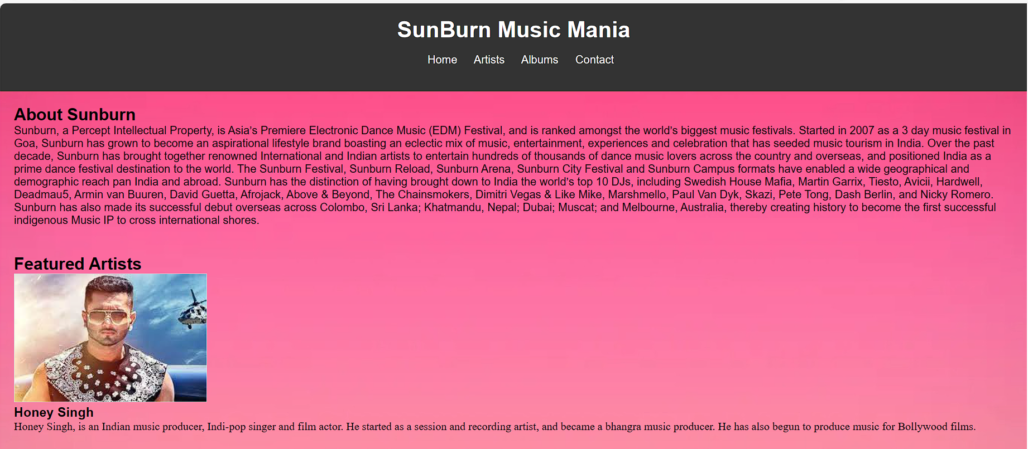

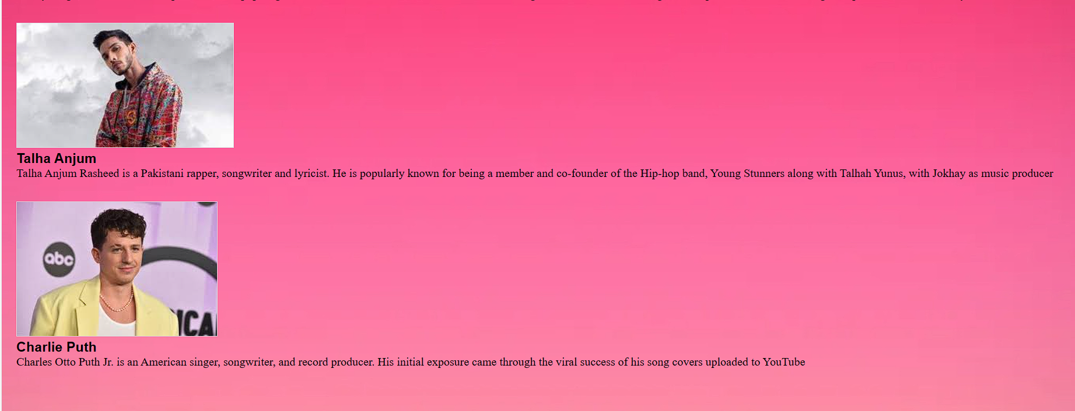

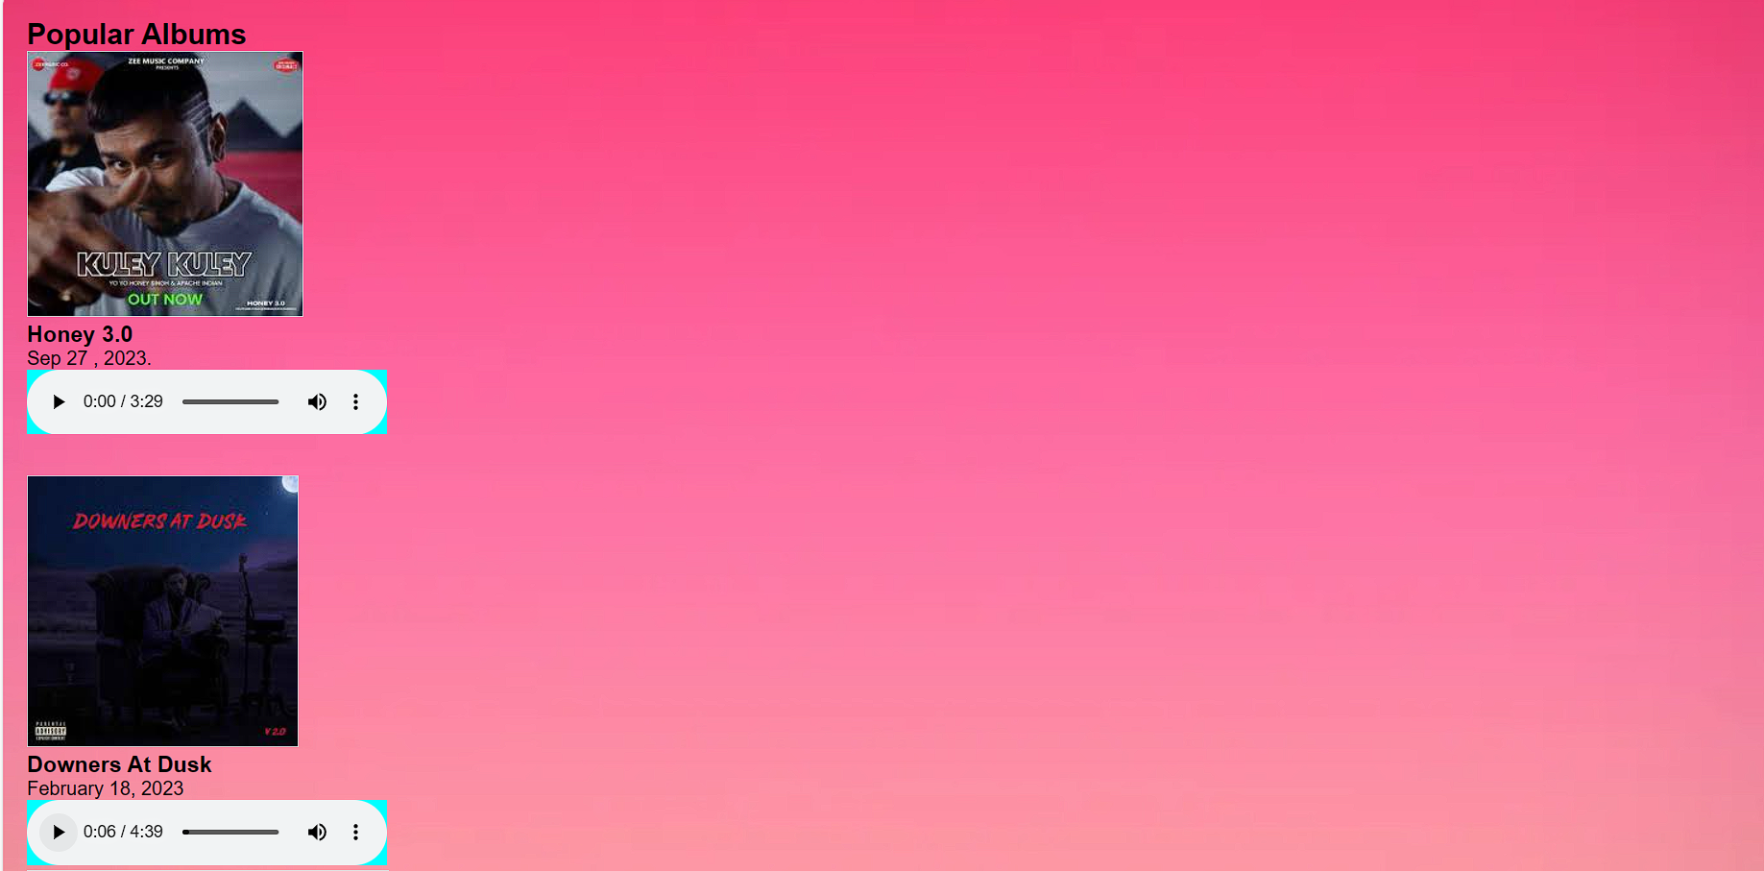

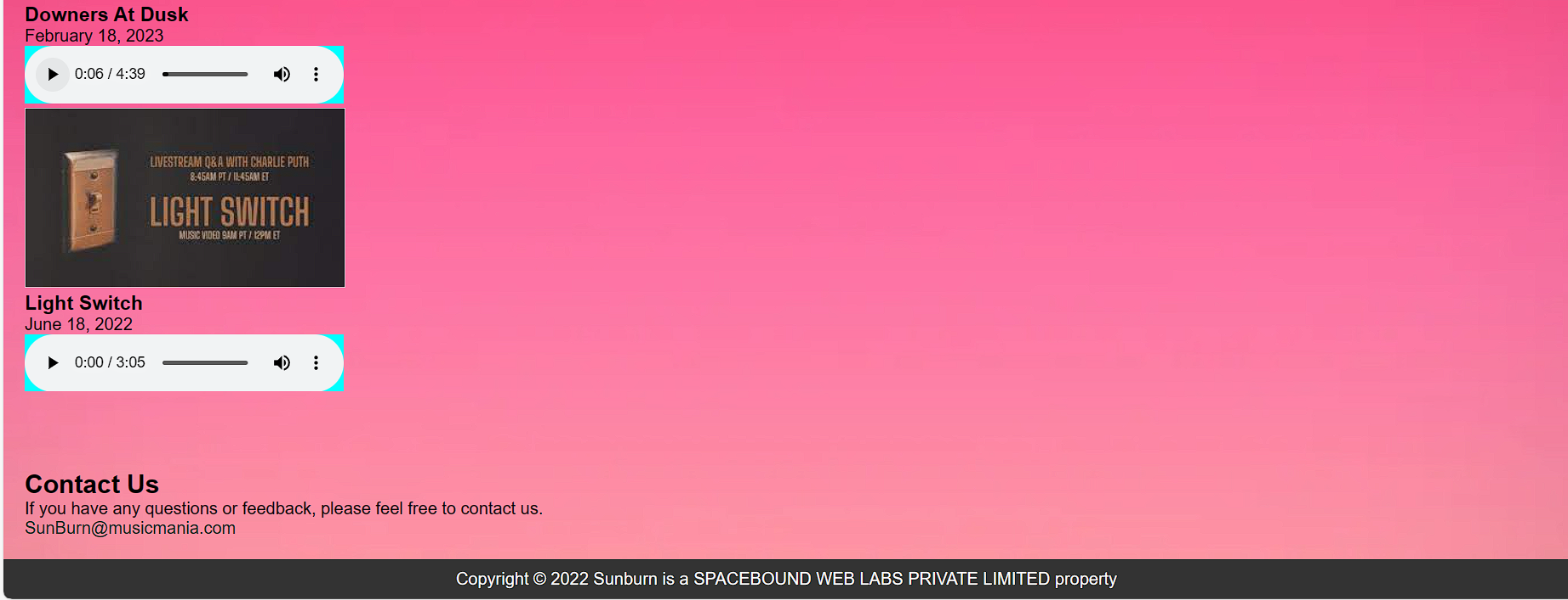

**Conclusion: A successful website of music mania is created html and css.**